

Bilateral integration in virtual reality

Interim Report

DT211C

BSc in computer science infrastructure

**Mykolas Kubilius**

**C20321456**

**Dr Bryan Duggan**

School of Computer Science

Technological University, Dublin

**15/11/2023**

Abstract

Virtual reality is becoming really popular in the science industry such as the medical and psychological fields. virtual reality is being used by people to help others with mental health problems and other mental challenges, but how would the virtual world help people who have different types of disabilities or different type of mental challenges?

Virtual reality can help people by creating a virtual environment that is both safe and user friendly, it also provides a fun and engaging experience for users which will encourage them for frequent usage that aims to improve their mental health. Bilateral integration is what I am currently focusing on as I see that it has a lot of potential to help out kids with mental difficulties work on coordination, there are currently real-world example of exercises used by teachers and therapists. This report details all the development of a bilateral integration exercises in VR using the game engine Godot which will be implemented into the Meta Quest 3, the whole game will be coded in Godots very own language called GDscript, but it also uses C++ and C#. the report will also cover the creation of 3D objects and assets as well as game mechanics and integration of VR features such as grabbing different 3D objects and interaction with the virtual environment. Several test cases will be provided to test out each induvial levels that contain different types of bilateral integration exercises to see if it matches the requirements for a healthy and useful exercises to help out the kids. This project will greatly benefit young kids with mental challenges to overcome their lack of hand and eye coordination.

Declaration

I hereby declare that the work described in this dissertation is, except where otherwise stated, entirely my own work and has not been submitted as an exercise for a degree at this or any other university.

Signed:

Mykolas Kubilius___

15/11/2023

Acknowledgements

Body text

Table of Contents

1. Introduction 7

1.1. Project Background 7

1.2. Project Description 7

1.3. Project Aims and Objectives 7

1.4. Project Scope 7

1.5. Thesis Roadmap 7

2. Literature Review 8

2.1. Introduction 8

2.2. Alternative Existing Solutions to Your Problem 8

2.3. Technologies you’ve researched 8

2.4. Other Research you’ve done 8

2.5. Existing Final Year Projects 8

2.6. Conclusions 8

3. System Design 9

3.1. Introduction 9

3.2. Software Methodology 9

3.3. Overview of System 9

3.X. Other Sections 9

3.X. Conclusions 9

4. Testing and Evaluation 10

4.1. Introduction 10

4.2. Plan for Testing 10

4.3. Plan for Evaluation 10

4.4. Conclusions 10

5. Prototype Development 11

5.1. Introduction 11

5.2. Prototype Development 11

5.3. Other Sections 11

5.4. Conclusions 11

6. Issues and Future Work 12

6.1. Introduction 12

6.2. Issues and Risks 12

6.3. Plans and Future Work 12

6.3.1. GANTT Chart 12

Bibliography 13

# 1. Introduction

## Project Background

What is bilateral integration otherwise known as bilateral coordination? Well, it’s the ability for both sides of the brain to work together in a coordinated manner, this is shown when the left side of the brain is working on conjunction with the skills associated with the left side of the brain and also the skills associated with the right side of the brain. In short it means that that brain works together in unison.

Skills associated with the right side of the brain.

* Creativity (thinking and imagination)
* Art, drawing and other creative skills that is artistic.
* Musical skills

Skills associated with the left side of the brain.

* Speech and language
* Problem solving
* Handwriting
* Logic
* Memory for spoken/written messages.
* Linear thinking

Bilateral coordination develops from a young age, its noticed when a newborn starts to use both of their hands near their mouths like a milk bottle, when the child grows it begins to use its hands to crawl by using both hands to push the body forward one step at a time.

But not all babies have the skills to move their hands in unison. Sometimes differently mental health problems hinder that, those kids don’t have bilateral coordination since they weren’t thought it. Which is why there are plenty of exercises that help out with helping the kids achieve bilateral coordination. These exercises can include,

* Tying a shoelace
* Typing
* Writing
* Playing an instrument
* Pouring water into a cup
* Reaching out for objects
* Bouncing a balloon in the air with a broomstick

(Beck, 2022)

## Project Description

The project’s main goal and objective is to develop a simple level-based game that contains a different set of bilateral integration exercises that is currently being used in the real world. Using these examples, the game will contain a safe and fun virtual environment that the user with coordination difficulties can easily pick up a VR headset and pick up the controls then they can dive straight into the levels and test out how well their brains can coordinate together as there is a left side and right side of the brain. These exercises can range from holding a broomstick or a long stick with both controllers using the grip VR feature and have a light balloon like 3D object bounce up in the air every time the user uses the stick to push the object upwards. Other exercises can involve using both hands to hold a virtual marker and draw something on a whiteboard or use one hand to draw the infinity symbol over and over again until they keep their marker inside of the line.

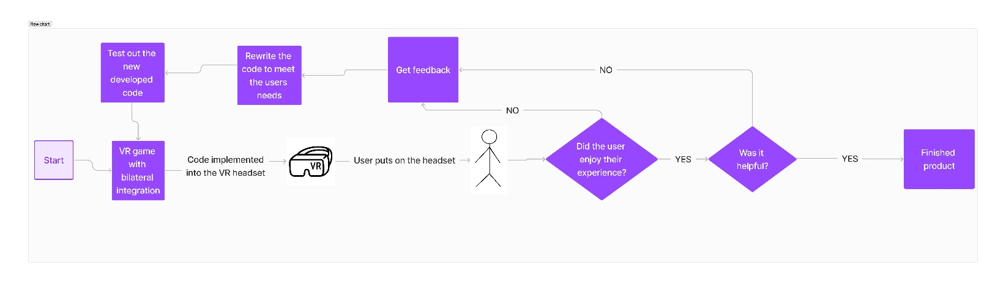

## Project Aims and Objectives

My main objective is to implement a VR game that has different types of levels that have different exercise implemented into each level. I want my users to feel like that VR experience is helping them out with bilateral coordination and that it encourages them to keep playing the games and helping them with their bilateral coordination.

Make an immersive experience that involves adding an immersive environment like a classroom or the outdoors where the user can interact with objects or scenarios that need the usage of both hands.

Develop hand-eye coordination that demands the users to coordinate between hand movements and visual perception which will help the users hand and eye coordination in a VR environment.

Educational purposes that allow the development of using both hands in unison that aids in learning through interactive tasks such as writing on a whiteboard.

Implement gameplay mechanics that require users to use both hands effectively, adding that engagement to gaming experiences.

Implement user feedback and progress tracking, this helps provide a friendly and productive user experience for the individual. The progress tracking enables users and teachers to monitor their improvements overtime.

## Project Scope

This project will focus on developing a level-based VR game that contains different types of bilateral integration exercises. The whole game will be made using Godot in a simple 3D safe world environment where it will be played on the Meta Quest 3. The user should be able to easily pick up the headset and put it on, hold both of the controllers in each hand and follow along with the instructions that are placed inside of each level, this allows the user to understand what task they have to accomplish in order to proceed to the next level.

I won’t be implementing accounts for each user as I think that would take a longer time to implement since it would require each user to have the perfect settings. It would be easier that way since I will be focusing on perfecting the exercises for each level that the kids could enjoy. I will also not implement a multiplayer functionality so that there won’t be a need for account registration or any profile making so that way the user can simply put on the headset and start learning and training their brains to use hand-eye coordination.

## Thesis Roadmap

One sentence explaining what each of the following chapters is about.

# Literature Review

## 2.1. Introduction

In this chapter, I will discuss about similar alternative approaches to mental heal problems that involves the usage of virtual reality.

## 2.2. Alternative Existing Solutions to Your Problem

There are a few companies that use virtual reality to help with mental health, they dive to help out using meditation and other science-based technologies, but my project focuses on bilateral coordination, this does fall under the mental health category, but my project focuses on helping one problem.

## 2.2.1 Amelia by XRHealth

The Amelia VR Platform is easy to use, fast, and affordable. Amelia Virtual Care – formerly known as Psious – provides a virtual reality platform used by therapists who perform mental health assessments and interventions. Through close collaboration with leading public and private institutions, we are proud to advance research and promote evidence-based care for better mental-health practices, globally.

The benefits of VR in mental health are supported by 30+ years of evidence and over 1000+ studies. As evidence of the advantages of VR in mental health accumulated, adoption of its use by mental health professionals has steadily grown.

Their mission is to improve mental health through the use of science-based new technologies and their vision is to become the world leader of virtual reality in healthcare.

They value a positive social impact.

They value a global mindset.

They value Entrepreneurship.

They value Passion & empathy.

Their history

The name Amelia Virtual Care comes from the first-ever woman to fly across the Atlantic Ocean, Amelia Earhart.

Amelia left England for the United States on an air crossing that lasted more than 20 hours and 40 minutes–a daring accomplishment that went against predictions and showcased her tenacity.

Xavier Palomer, Founder of Amelia.

“Amelia started in 2014 while I was having a drink with two friends 8 years ago. The first one was afraid of flying and mentioned the problems generated by this situation. The other one, a psychologist, responded how VR could be a tool to address his problem.

I found out that literature regarding VR technology was extensive and scientific validation quite robust. Yet, despite this incredible background, the technology was not accessible to professionals and patients worldwide. I saw an opportunity. At Amelia, we bring technology based on VR to a market-ready solution. This is our core!”



(‘About Amelia Virtual Care | VR Software for Mental Health’, no date)

## 2.3. Technologies you’ve researched

A virtual reality game can be implemented using a wide variety of technologies and software’s, underneath is a list of technologies that I have investigated.

## 2.3.1

## Meta Quest 3

The Meta Quest 3 which can be also commonly known as Oculus Quest 3 is a virtual reality headset that was developed by Meta platform and Meta is founded by Mark Zuckerberg. Meta officially revealed the Meta Quest 3 on June 1st and then launched the headset through the Meta Connect 2023 event on September 27. During the online livestream, Meta confirmed that the Quest 3 will start shipping on October 10, 2023, with pre-orders going live right after the announcement was done. the Meta Quest 3 provides a 4K+ Infinite Display (2 LCDs with 2064 x 2208 pixels per eye) with a field of view by 110 degrees horizontal, 96 degrees vertical. It has a refresh rate of 90Hz (native), 120Hz (experimental), it weighs around 515 grams and has a storage capacity of 128GB or 512GB. It uses a Qualcomm Snapdragon XR2 Gen 2 CPU

The Meta Quest headsets are commonly used for Virtual reality gaming. As shown in the previous diagram, the Oculus Quest 2 was the leading in unit sales then the other VR headsets

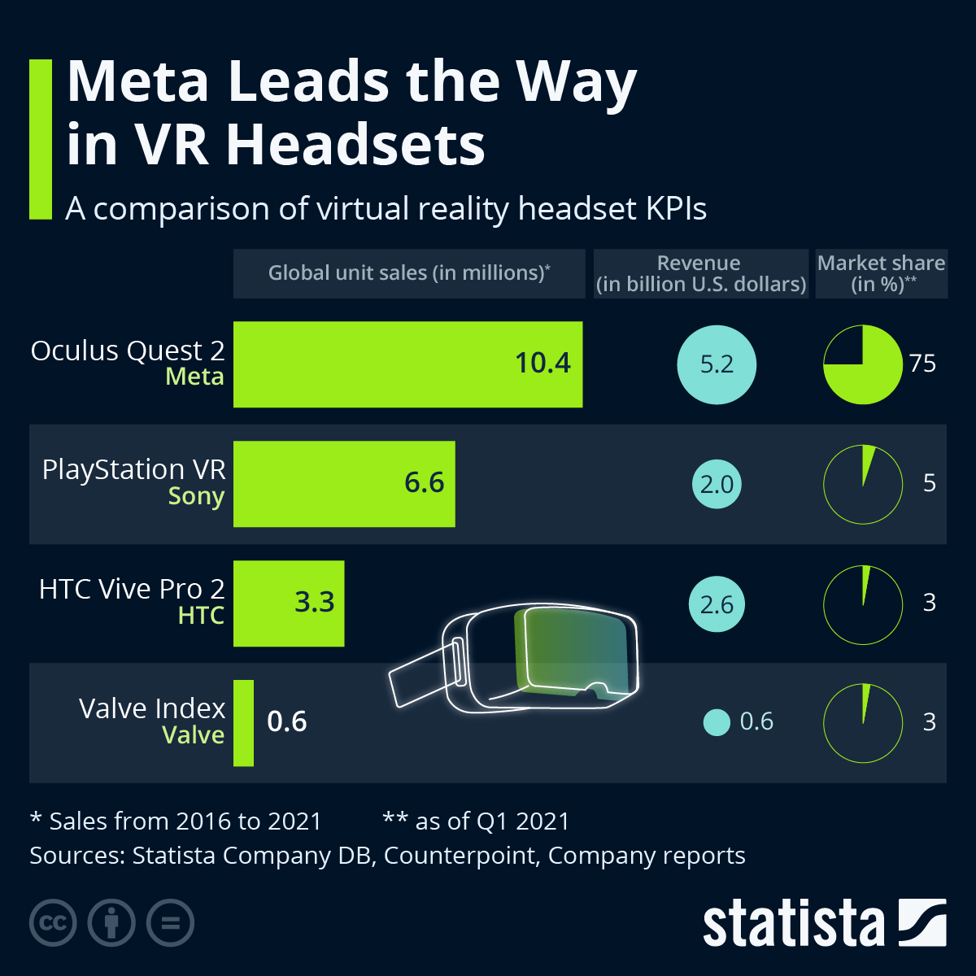

## 2.3.2 Godot

Godot is a general purpose 2D and 3D game engine that is designed to support all sorts of projects, it can be used to create games or applications that can be released on desktop or on mobile devices, as well as being published on the web. Godot was developed by an Argentinian game studio and its development started in 2001 before having its open source released in 2014. Below are some images of games that were created using Godot

Godot comes with a fully-fledged game editor with integrated tools that answers most people’s common needs. This includes a code editor, an animation editor, a tile map editor, a shader editor, a debugger, a profiler and many more. Below is an illustration of what Godot has to offer.

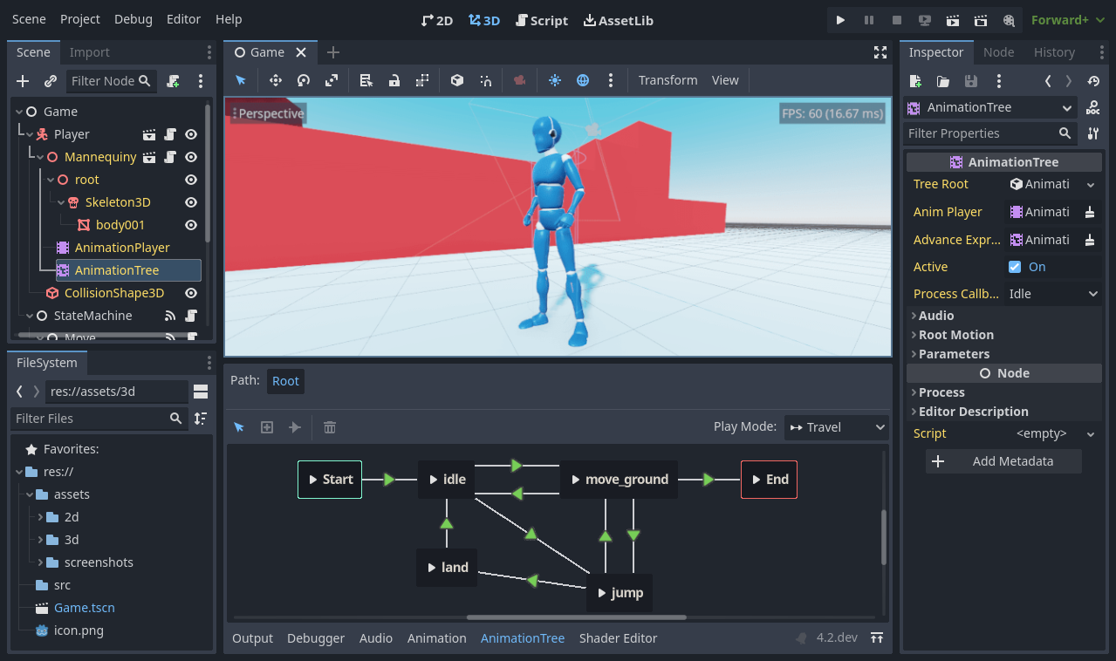

Godot offers its very own programming language called GDscript, you can also code in C# which is the more popular programming language for developing games, but with GDExtensions, you can write gameplay or develop high-performance algorithms in C or C++ without compiling the engine.

(*Introduction to Godot*, no date)

## 2.3.3 Unreal Engine 5 (UE5)

The unreal Engine 5 is the latest version of unreal Engine, its one of the most powerful and popular game engines that contains features such as Nanite, Lumen, World partition system, Meta Sounds and animations

Nanite:

The unreal engine 5 uses nanite which is a virtualized geometry system that saves you the time when designing massive amounts of geometric detail, the enables designers to create wide ranges of surfaces. It also eliminates tedious tasks for loading in level of details and allows you to import film-quality art. With nanite you can just scan and go and not have to worry since it doesn’t impact performance and you would still get a real-time frame rate.

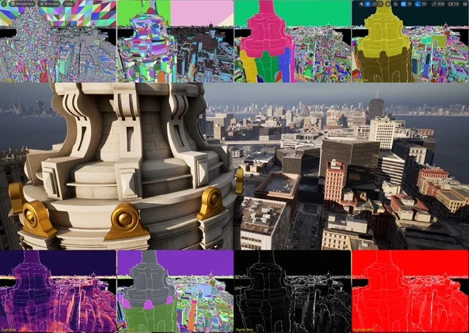

Lumen:

Lumen creates a realistic virtual world that comes down to lighting, with a fully dynamic global illuminations and reflections. Lumen allows you to make indirect lighting which reacts to direct lighting and geometry. For example, lighting can be adjusted to match the times of day and night using a light source like the sun, you can also create a flashlight that creates a bean of light. Lumen adjusts lighting from open, dynamic scenes down to the tiniest details.

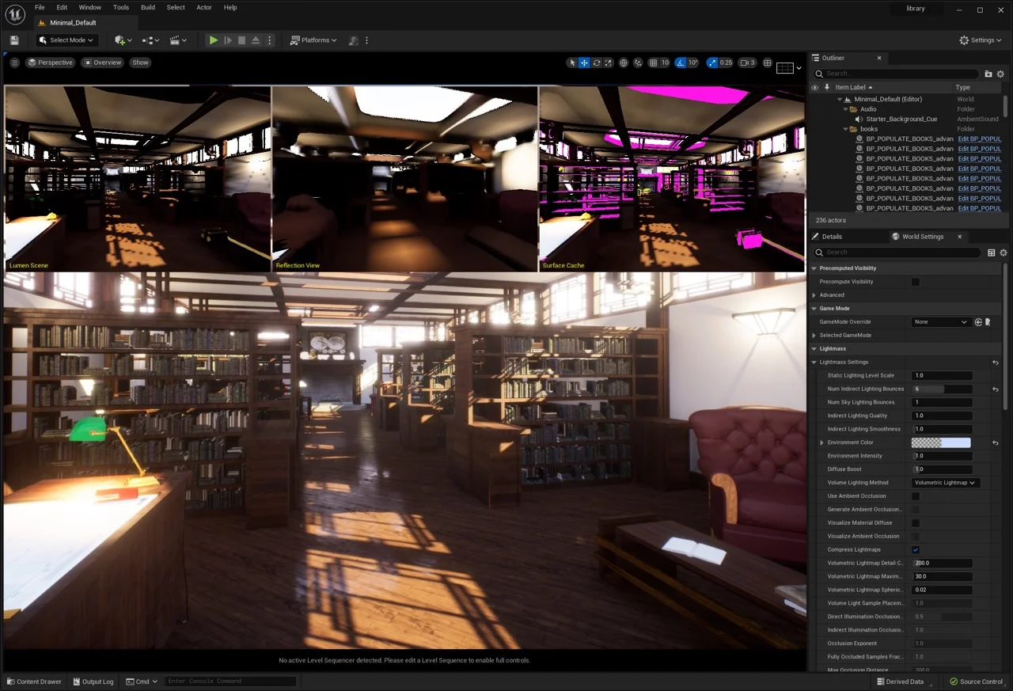

World Partition:

Unreal engine 4 is known for allowing users to create open world. But unreal engine 5 lets you accelerate the creation of large-scale world building and makes it easier to collaborate. The world partition system uses a grid to map out sublevels of an entire universe. You can manage complex levels that can load and unload as a player goes across the landscape. Also, the one file per actor system helps teams work in parallel. It reduced overlap by saving data as external files per contributor.

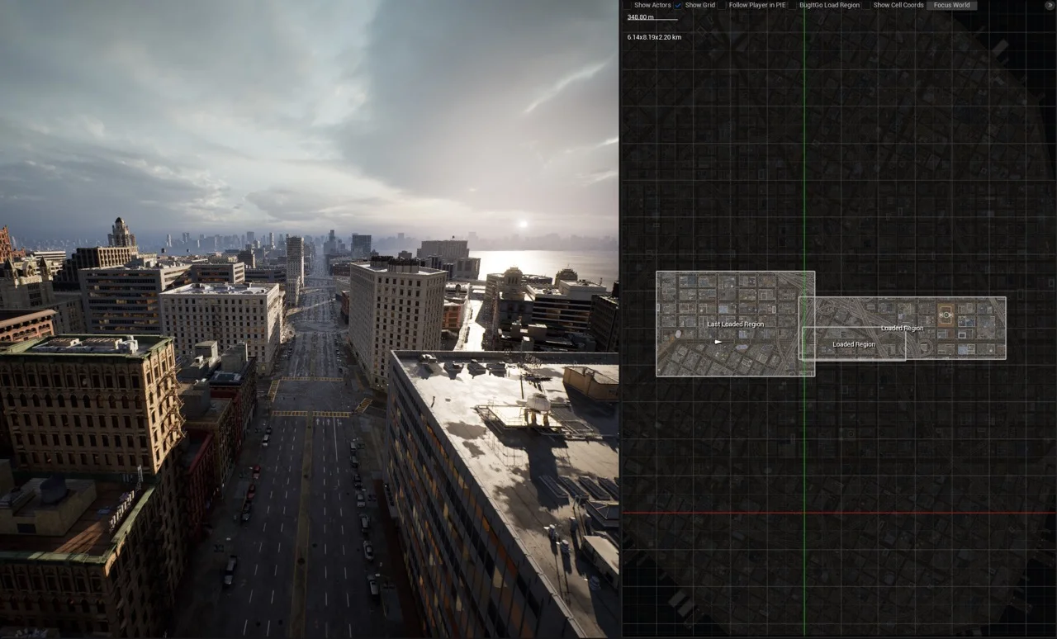

## 2.4. Other Research you’ve done

## 2.4.1 XR interaction toolkit

Godot’s XR toolkit provides the user a with a modular XR system that abstracts many of the different XR platform specifics away from the user. At its core sits the XRserver which acts as the central interface to the XR system that allows users to discover interfaces and interact with the components of the XR system

Each supported XR platform is implemented as an XRInterface. Supported interfaces register themselves with the XRServer and can be queried with the find_Interface method on the XRServer. When the desired interface is found it can be initialised by calling initialize on the interface.

OpenXR is a new industry standard that allows different XR platforms to present themselves through a standardised API to XR applications. This standard is an open standard maintained by the Khronos Group and thus aligns very well with Godots interests.

The Vulkan implementation of OpenXR is closely integrated with Vulkan, taking over part of the Vulkan system. This requires tight integration of certain core graphics features in the Vulkan renderer which are needed before the XR system is setup. This was one of the main deciding factors to include OpenXR as a core interface.

## 2.5. Existing Final Year Projects

## 2.5.1 Project 1: VR Safari

Student: Elihu Essien-Thompson

Description (brief):

VR safari is a game where the user is placed into a Safari viewing experience while attempting to take pictures of the animals to gain points while the animals roam freely. The player is allowed five minutes to gain points before the game is over and the score is shown.

## 2.5.2 Project 2: EvolVR- Investigating procedural Ecosystems and Evolution

Student: Ryan Bryne

Description (brief):

The project aims to make a virtual ecosystem with diverse animal groups while simulating their evolution over time. These animals adapt to procedurally generated environments by passing their traits through genetic mutations. The animals AI is being controlled by a behaviour tree.

## 2.6. Conclusions

A well designed and written game that is used to help people with bilateral integration requires extensive and comprehensive research and also requires the accurate utilization of technology. This project utilized the Godot game engine for modelling the objects and the world while using Godots own language GDscript to write out scripts and the game is available to be played on any Meta Quest.

# 3. System Design

## 3.1. Introduction

This chapter expands on the detailed research regarding different software methodologies that was implemented into the VR game. Along with some early designing stages of the project.

## 3.2. Software Methodology

A software development methodology is a process by which developers design, implement and test new software programs. Following a methodology benefits developers because it lays out a structured sequence of steps that guide professionals through each stage of development. it also can follow a design philosophy, which can help developers align their process and the product’s features with its functional goals. This project was run by Agile and waterfall methodologies.

## 3.2.1 Agile Methodology

Agile methodology is a type of project management methodology. It emphasises a fast and flexible approach by allowing the development team to divide larger projects into smaller and easier to handle tasks. The team can then complete these smaller tasks in shorter iterations while gaining feedback on these smaller portions for a more consistent communication with the client and its test users. This methodology is useful for reducing while also avoding risks, expediting development, improving customer satisfaction and also reducing redundancies. Since developers gain client feedback through the development and testing cycle, this can be a great method to use for projects that require significant collaboration.

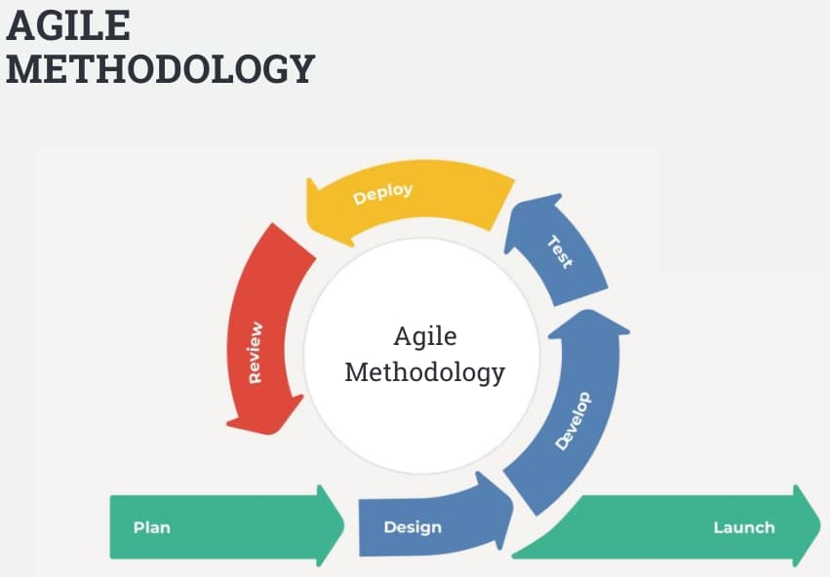

## 3.2.2 Waterfall Methodology

The waterfall methodology involves breaking a task down into a sequence of stages. With this process, developers need to complete each stage in its entirety before moving to the next step. Although this process may be less effective than those where developers can work on several stages of the project concurrently, the waterfall method is effective for ensuring thoroughness at every level of project development. this method also minimizes redundancies because it prevents overlap between tasks at different stages.

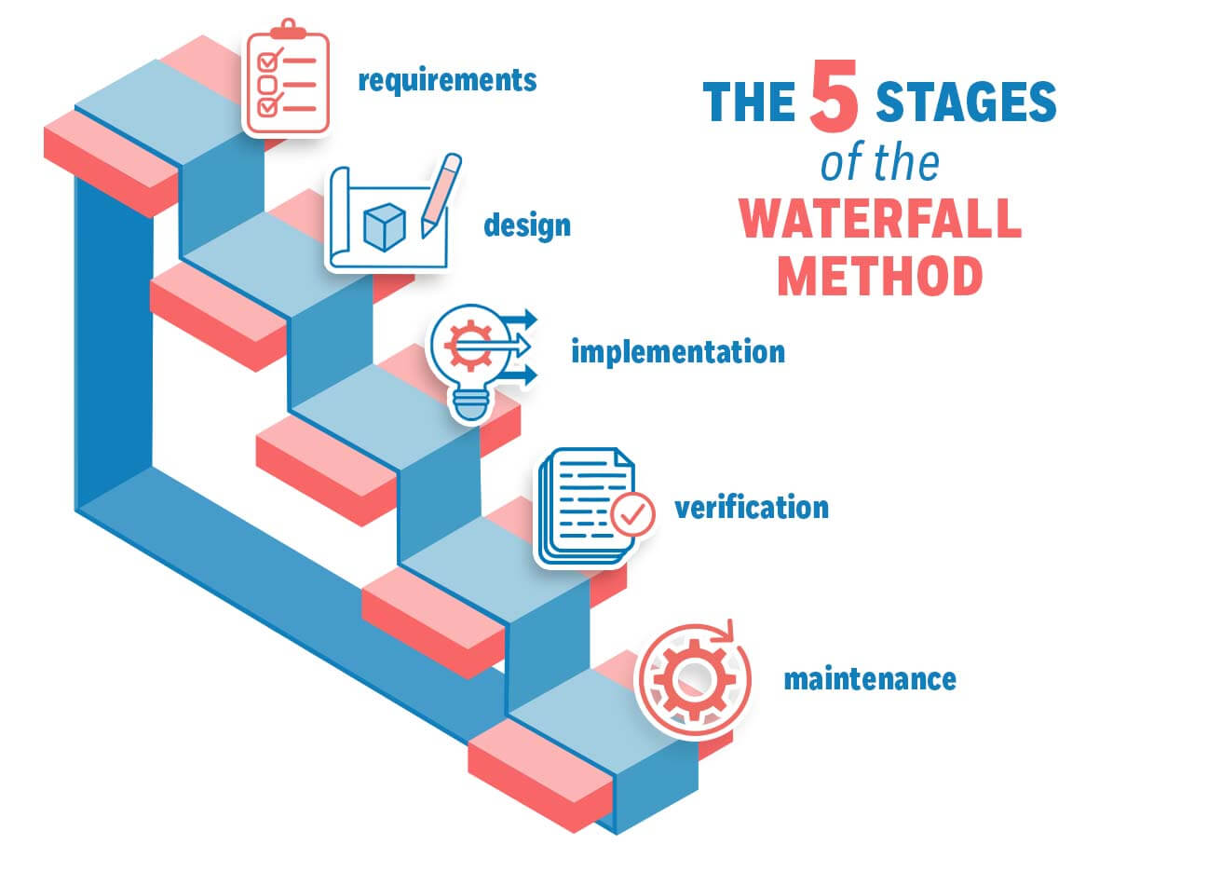

## 3.3. Overview of System

This VR game that is based on bilateral is developed using the following VR-based technical architecture. There are different components that need to help each other out in order to make a functioning VR game. For this you would need the logical layer which involves the game engine and code. And you would need the presentation layer which involves the computer as well as the VR headset and controllers.

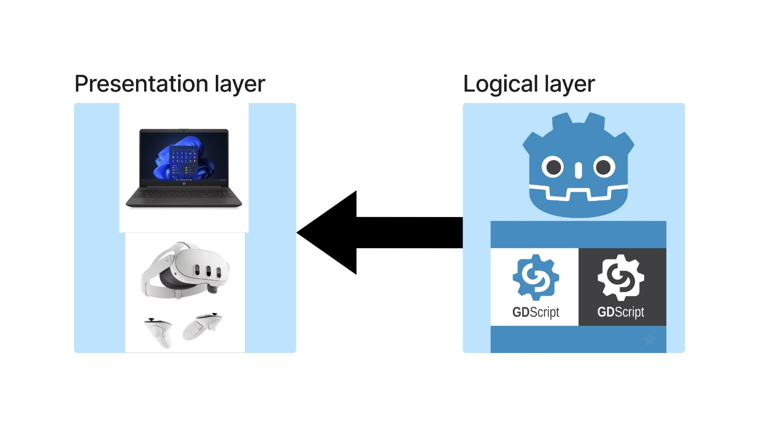

This project used a couple of technologies to make and build the project. these include the Meta quest 3 Virtual reality headset and controllers, Godot 4.1.3 game engine with the GDscript programming language. These were used to develop the bilateral integration game

## 3.3.1 Flow chart diagram

The flow char diagram shows the overview of what the process will look like. In the flow chart the user will put on the headset and use the controllers to play the game, the controllers are used for interaction with the virtual environment within the game. The player runs the game in a 3D environment with the headset. The player can control the behaviour of the different objects within the virtual world using the headsets controllers with both hands. The game will have levels that the player will have to perform in order to proceed to the next level. These levels use real world examples that teachers and therapists use to help young children with bilateral integration.

## Meta quest 3:

In order for the player/user to feel like they are the ones doing certain actions within the game, VR heavily relies on immersion, this introduces a simulation-based technology that enables the player to interact with the virtual environment and be immersed in the world around them with different 3D objects placed for them to play around with.

## 3.3.2 Use case diagram

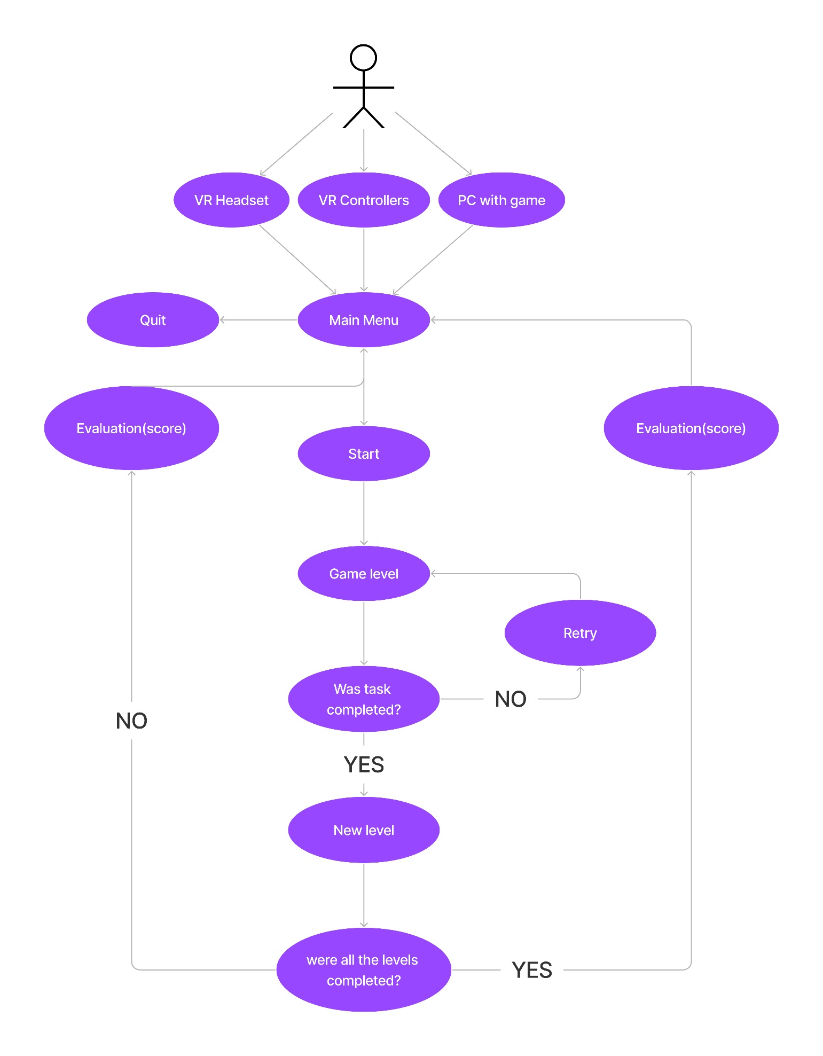

asda

## 3.X. Other Sections

## 3.X. Conclusions

# 4. Testing and Evaluation

## 4.1. Introduction

## 4.2. Plan for Testing

## 4.3. Plan for Evaluation

## 4.4. Conclusions

# 5. Prototype Development

**As least 2 pages, but as many as you like (but lots of code samples).**

## 5.1. Introduction

## 5.2. Prototype Development

## 5.3. Other Sections

## 5.4. Conclusions

# 6. Issues and Future Work

## 6.1. Introduction

## 6.2. Issues and Risks

## 6.3. Plans and Future Work

### 6.3.1. GANTT Chart

# Bibliography

‘About Amelia Virtual Care | VR Software for Mental Health’ (no date) *Amelia Virtual Care*. Available at: https://ameliavirtualcare.com/about-us/ (Accessed: 21 November 2023).

Beck, C. (2022) ‘Bilateral Integration’, *The OT Toolbox*, 15 September. Available at: https://www.theottoolbox.com/bilateral-integration/ (Accessed: 21 November 2023).

*Introduction to Godot* (no date) *Godot Engine documentation*. Available at: https://docs.godotengine.org/en/stable/getting_started/introduction/getting_started/introduction/introduction_to_godot.html (Accessed: 21 November 2023).